**ARAKAS KOKKINISTOS (Peas in tomato sauce)**

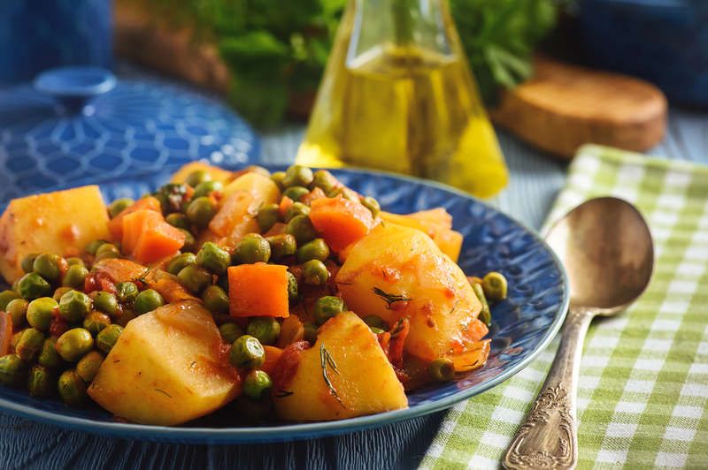

**INGREDIENTS**

450g /16 oz. peas (peeled)

120g /4 oz. olive oil

1 red onion, chopped

2 carrots, sliced

2 potatoes, cut in cubes

1 teaspoon tomato puree

300g /10 oz. tin Italian chopped

1 vegetable stock cube/pot

1–2 fresh onions, chopped

2 tbsp fresh dill, chopped

salt and freshly ground pepper

**METHOD**

* Heat half the olive oil in a medium sized pot. Sauté the red onions and fresh onions until soft. Add carrots, potatoes and tomato puree and sauté 2 more minutes.
* Add the grated tomatoes and enough hot water so that the ingredients are covered just a bit.
* Bring to a boil and boil for 15 minutes (without the lid), until the potatoes have softened a bit.
* Add the peas, fresh dill and the remaining olive oil and season well with salt and pepper.
* Mix well, lower the heat and simmer for 10 minutes, until peas are soft and water is gone, (they should only be left with the olive oil.)
* Serve warm or at room temperature with crumbled feta cheese and crusty bread.