**BEEF WITH MUSROOMS (Serves 3-4 people)**

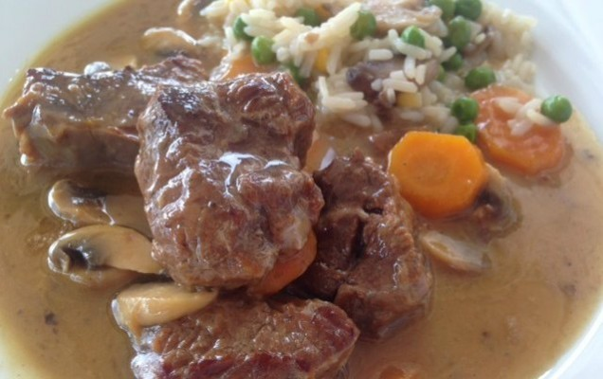

**INGREDIENTS**

1kg beef, sliced

1 pod or cube beef stock

2 medium onions, chopped

2 garlic cloves, chopped

50ml olive oil

50gr butter

200ml dry white wine

Juice of 2 lemons

1 tsp flour or cornflour

2 carrots, sliced

10 mushrooms, sliced

salt and pepper

**METHOD**

* Wash the meat. In a pot, heat the olive oil and butter and sauté the meat. Once brown, add the garlic and onion and sauté for a further 2-3 minutes.
* Add the wine, salt and pepper, stock pod/cube and top up with warm water or until the meat is just covered. Cover the pot and simmer the meat at medium heat for 50 minutes.
* Then add the lemon juice, carrots and mushrooms, and cook for a further 25 minutes, checking occasionally to see if more water is needed.

Before taking the food away from the heat, take a spoonful of the stock and dissolve the flour or corn flour in it, then add pack to the pot, and simmer for 5 more minutes. Serve with rice or chips.