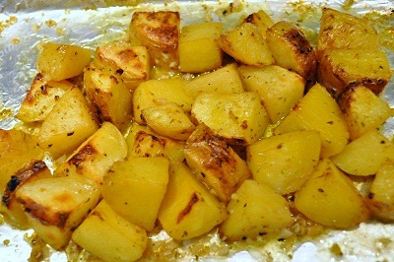**GREEK POTATOES**

**INGREDIENTS**

6-8 potatoes

1/2-1 cup olive oil

2 tbsp oregano

salt and pepper

juice of 2 lemons

1 tbsp mustard (Optional)

1-2 cloves of garlic (Optional)

**METHOD**

* Preheat the oven and peel and wedge the potatoes.
* Rinse them and place them in the baking dish. Add the salt, oregano, pepper, mustard (optional), garlic (optional), and olive oil and mix well.
* Cover with foil and put in the oven,
* Bake for about an hour.
* Take the foil of and check if they are almost cooked topping up with water if necessary until golden brown.

**Tips**

for extra flavour, whisk together some of the olive oil from the baking tin with 1-2 tbsp mustard, lemon juice, and a little salt. Pour over the warm potatoes and serve.