**Greek Meatballs Recipe**

**(makes around 20-25 meatballs)**

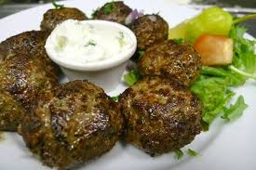

**INGEDIENTS**

1 Kg Mixed Pork and Beef mince

2 Medium size onions peeled and grated (not chopped)

1 bunch fresh mint roughly chopped

½ bunch flat parsley roughly chopped

4 sliced or equivalent white bread (preferably stale)

2 eggs

2 tablespoons oregano

1 tablespoons salt

1 teaspoon black pepper

**METHOD**

* In a bowl or measuring jug put the bread and add water so it softens (you will need to allow at least an hour to ensure all the bread is moist)
* Once the bread is ready, darin any excess water and add all the ingredients together and neat gently until it all mixed and feels quite doughy. (it shouldn’t take more than 5 minutes).
* Pick the mixture and make the meatballs at the size you want.
* Put some flour on a plate and cover them well before frying. You can shallow or deep fry.
* When they are ready they should be crispy on the outside and soft and moist on the inside.
* Serve with mint yogurt or tzatziki.