**Maroulosalata (Lettuce and spring onion salad)**

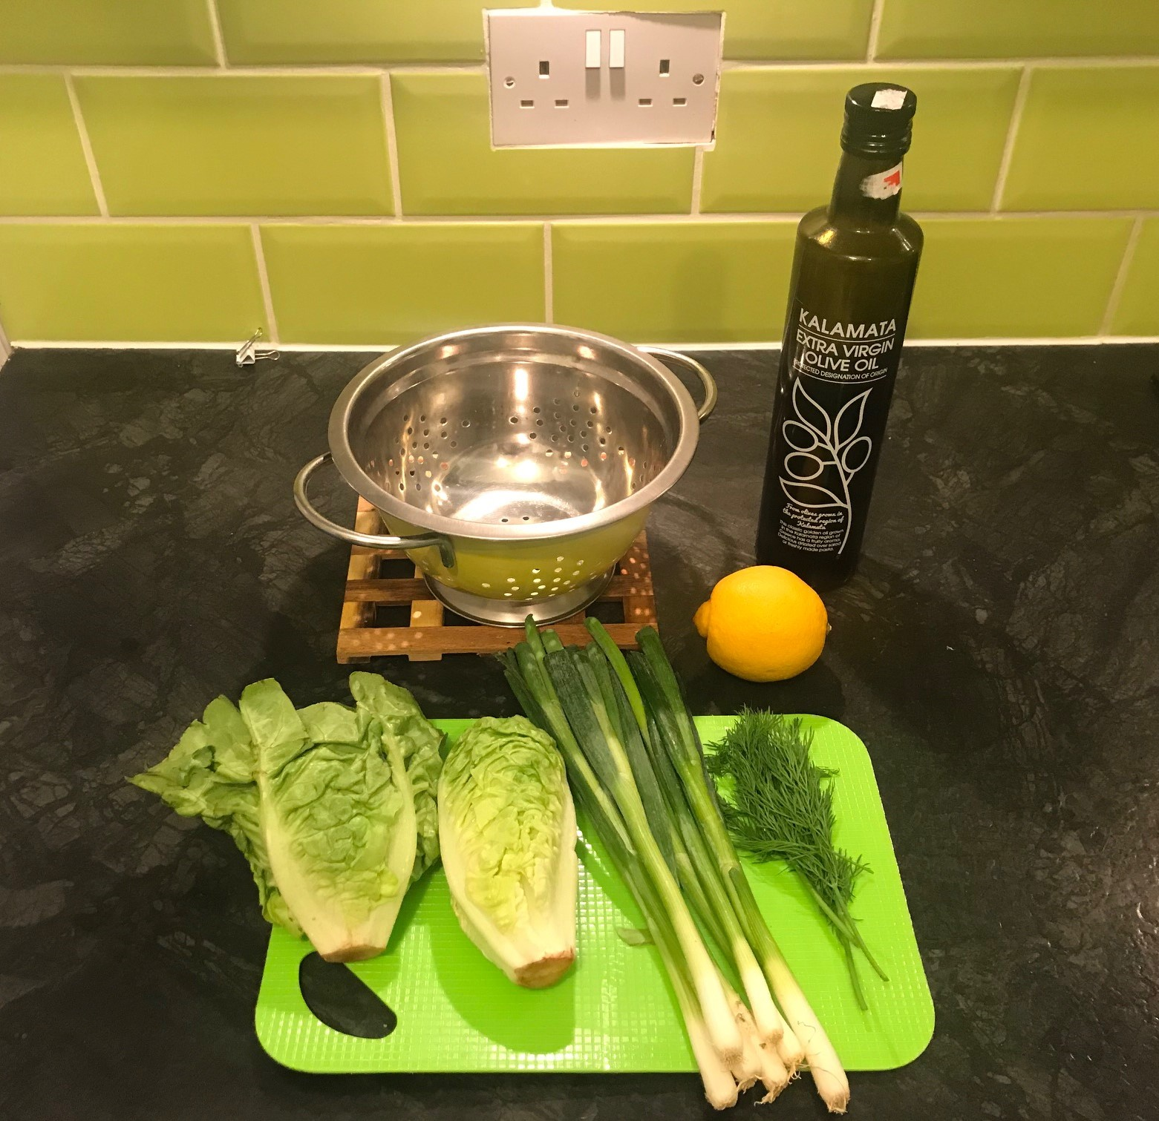

**INGREDIENTS**

* 1 Lettuce or 2 baby gem
* 1 Bunch spring onions
* Fresh dill
* Juice of one lemon
* 50ml Olive oil
* Salt & Pepper

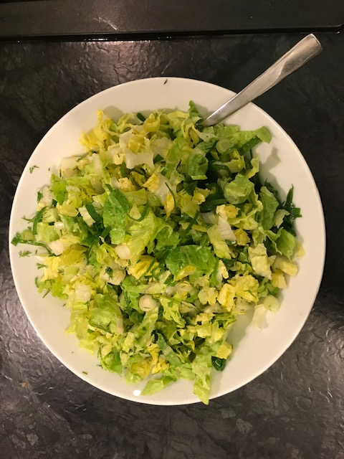

**METHOD**

* Wash lettuce and spring onions well
* Chop the lettuce, the onions and the dill
* In a bowl add the lettuce, onions and dill, drizzle the olive oil and add the juice of the lemon
* Season to taste and stir.