**PASTITSIO**

Serves: 8

**INGREDIENTS**

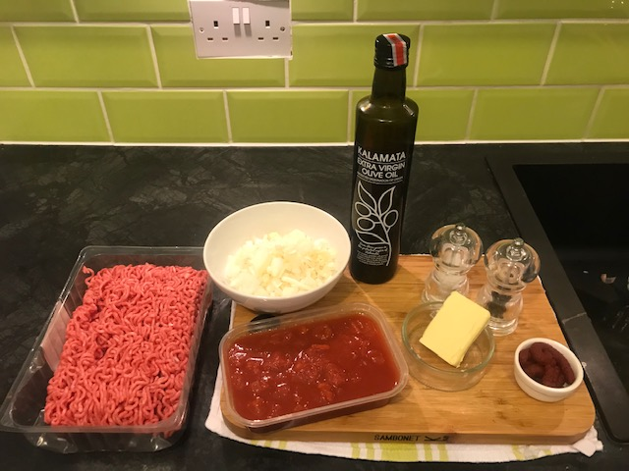

**For the meat sauce**

* 100ml olive oil
* 50gr butter
* 2 onions finely chopped
* 2-3 cloves garlic finely chopped
* 750gr beef & pork mince
* 350ml chopped Italian tomatoes
* 1 tablespoon good tomato paste
* 1 beef stock cub or pot
* 1 cinnamon stick or 1 teaspoon of ground cinnamon
* 1 teaspoon oregano
* Salt, pepper

**For the béchamel topping**

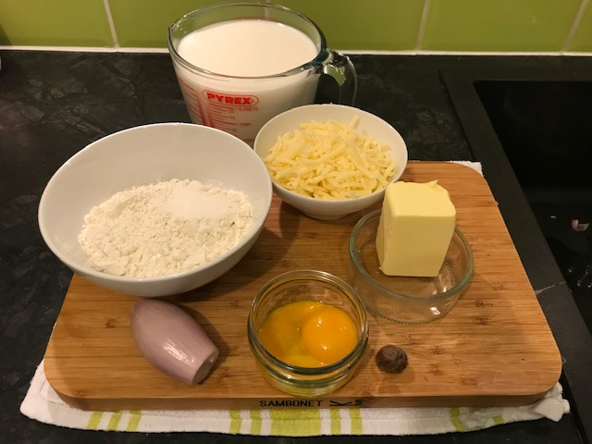

* 150gr plain flour
* 150gr butter
* 1.5lt milk
* 200gr grated cheese (extra mature cheddar)
* 3 egg yolks
* 1 shallot onion whole peeled
* 2 sticks fresh thyme or oregano
* salt: little
* pepper: freshly ground
* nutmeg: a pinch (optional)

**For the pasta**

* 500gr tubular pasta (penne)
* 1 tablespoon salt

**METHOD**

**Pasta**

* Boil the pasta in plentiful salted water and drain thoroughly.

**Meat sauce**

* Heat the oil and butter and sauté the onions and garlic until tender.
* Add the tomato paste and stir.
* Add the mince and cook for 8΄-10΄ until lightly browned.
* Pour in the plum tomatoes, stock, cinnamon, salt and pepper and simmer for 30΄-40΄ until liquid is reduced.
* If the sauce is too oily drain it but keep some for later.

**Béchamel**

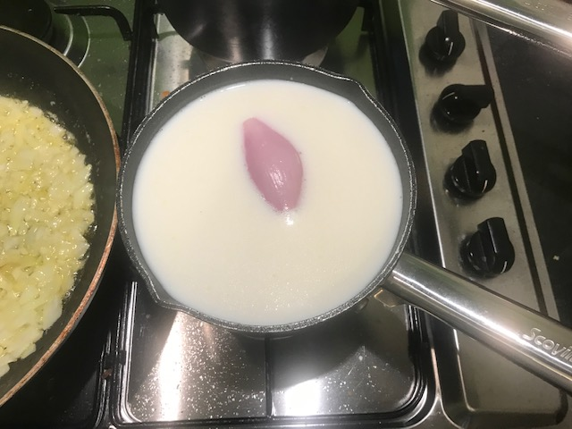

* In a pan put the milk, the shallot, the herbs and warm it up but do not boil
* Heat the butter and mix in the flour.
* Slowly pour in the milk stirring briskly all the time. Continue to stir until cream sauce thickens and add (off the heat) the cheese, salt, pepper, a pinch of nutmeg (optional) and the egg yolk one by one. Whisk well after each addition.
* Transfer the pasta to a buttered baking tray. Mix some of the meat sauce with the pasta, cover the pasta with a layer of meat sauce cover with film and let it rest for 15 minutes. This will help the past to absorb all the flavours from the mince juices and oils
* Finally, top with the remaining béchamel.

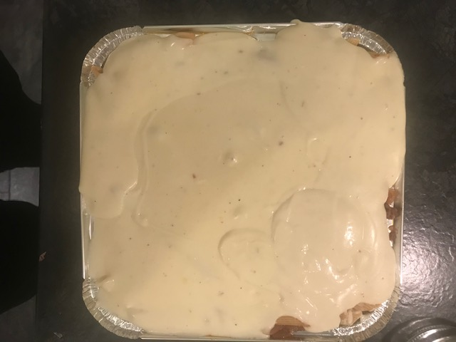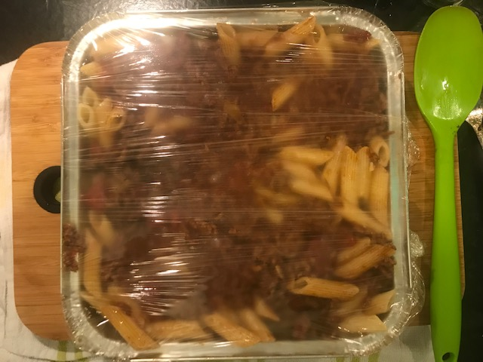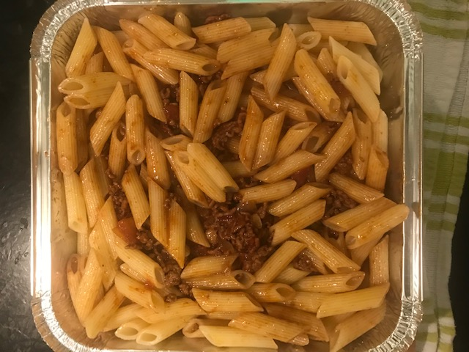

* Bake the pastitsio at 180 °C for approximately 1 hour or until the surface is golden brown. Cut into large rectangular pieces and serve with a nice green salad

