**SCRAMBBLE EGGS WITH TOMATOES and FETA - Serves 2**

**INGREDIENTS**

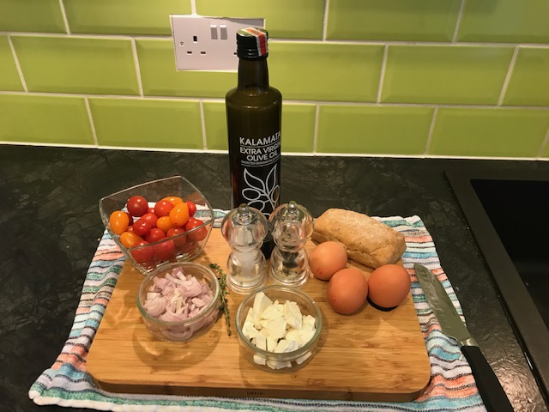

* 6 large eggs
* 2 tablespoons vegetable oil,
* 2 tablespoons olive oil.
* 50gr butter
* 50gr feta
* 1 shallot, finely chopped
* 300gr cherry tomatoes or 1 tin chopped tomatoes
* 1 teaspoon sugar
* 2 mini ciabattas or muffins cut in half
* Salt, pepper

**PREPARATION**

* Beat eggs with 1/2 teaspoon salt until smooth but not frothy.
* Heat the butter and vegetable oil in a largepan on medium-high heat until hot.

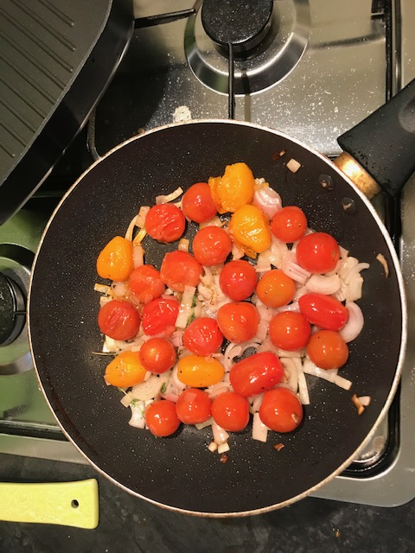

* Add schallots and cook for 2 minutes
* Add tomatoes and cook until soft.

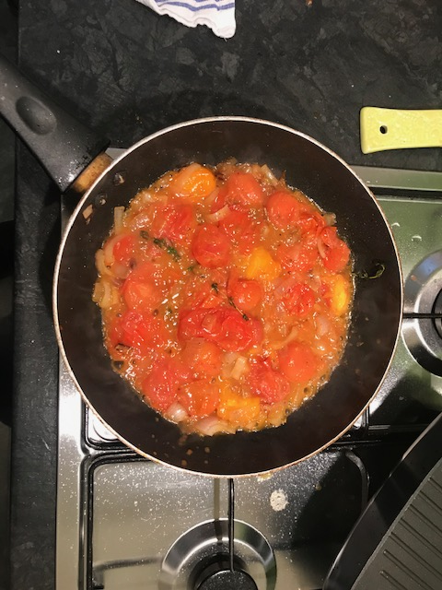

* Using a fork squash the tomatoes. If you are using tin tomatoes, cook until the juice is reduced
* Add eggs, season and cook string as you do when scrubbling until creamy or to your taste
* Drizzle the bread (cut face) with olive oil and season.

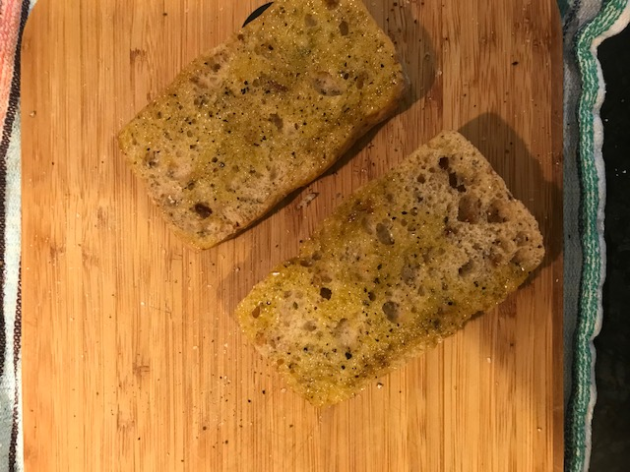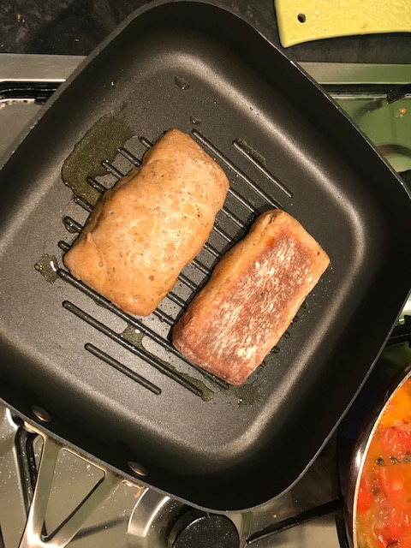

* On another hot pan, place the bread cut face down and fry the bread until is slightly toasted.

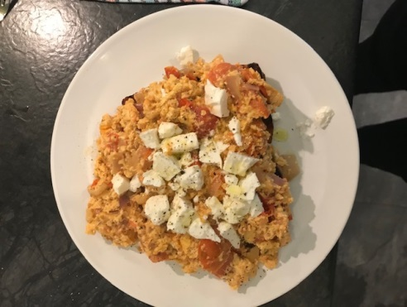

* Serve the eggs on the bread and crumble the feta on top and enjoy