**SIMPLY ROAST LEG OF LAMB**

**SERVES 4-6**

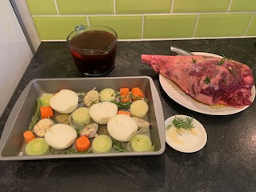**INGREDIENTS**

2-2.5 kg leg of lamb, bone in

Salt and pepper

50ml tbsp olive oil

1 whole garlic head (or 2 small), unpeeled, cut in half horizontally

4 cloves of garlic peeled, sliced

2 onions, halved

2 carrots cut thick slices (optional)

1 leek cut thick slices (optional)

2-3 bay leaves (optional)

4 rosemary sprigs

2 thyme sprigs (optional)

Dried oregano

1lt beef stock

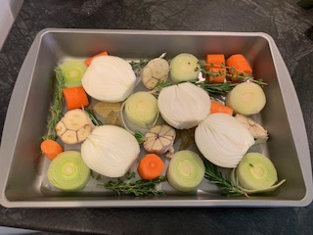**METHOD**

1. Preheat oven to 170C/335F (standard) or 150C/300F (fan/convection).
2. Place half head(s) of garlic, onion, and 2 sprigs of rosemary in a metal roasting pan (as well as carrots, leek, thyme and bay leaves if using).

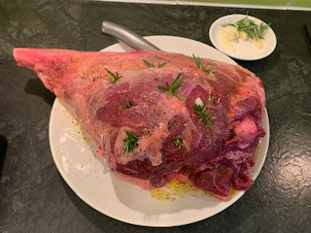

1. Take the lamb from the packaging and see which side has more meat and which is a bit fattier. Position the lamb on a large plate meatier side up, make small insitions with a sharp knife, stuff them with slivers of garlic and small picks of rosemary. Sprinkle with salt, pepper and dried oregano, pat it down, drizzle with olive oil.
2. 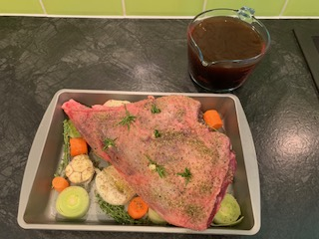Turn the leg over and place it in the roasting pan on top of the onions, garlic and the rest, fattier side up, and give it the same treatment with garlic slivers, rosemary, salt, pepper, oregano and olive oil.

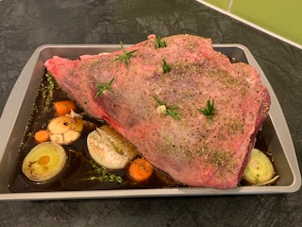

1. Pour in the beef stock, some of the meat will be submerged, that is fine.
2. Cover the pan with foil, place it in the oven and roast for 4.5 hours

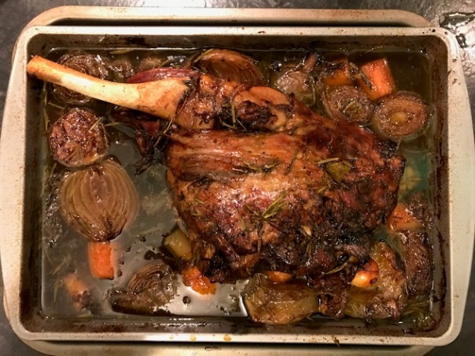

1. Remove from the oven, remove foil. Turn lamb over. Check it to ensure the meat is tender (pry a bit off with a fork). If not, return, covered, to oven.
2. Return uncovered lamb to oven for a further 45 minutes or until well browned.

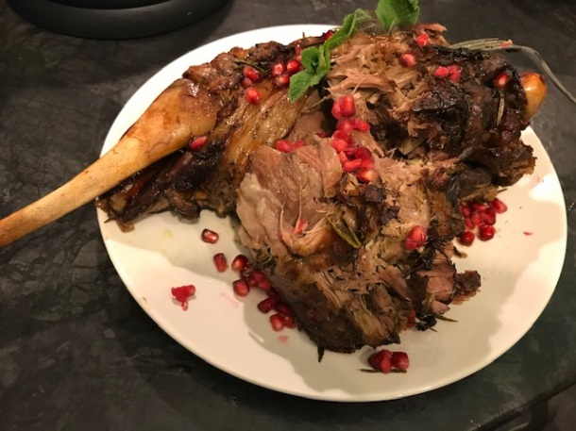

1. Remove lamb, spoon over pan juices generously. Transfer to serving platter, cover loosely with foil while you make the gravy (stays warm for 1 - 1.5 hours).

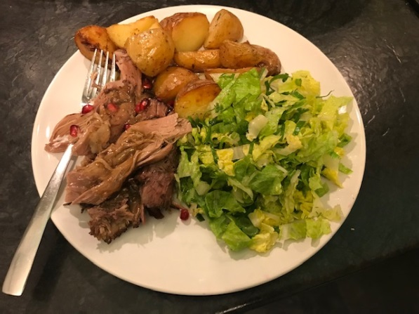

**TIP**

Perfectly serve with Greek potatoes and Marouli salad