Orange-Scented Almond and Olive Oil Muffins

Makes 12

**INGREDIENTS**

* 1 cup sugar
* 4 large eggs, at room temperature
* 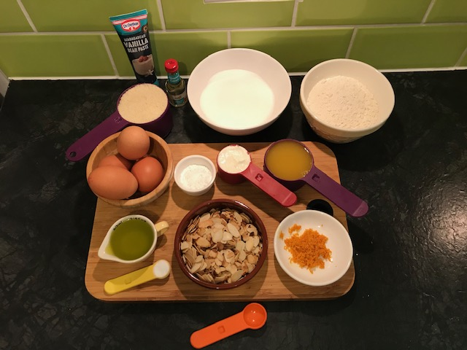1/4 cup plain whole milk Greek yogurt, at room temperature
* 1/2 cup fresh orange juice, at room temperature
* 1/4 cup extra-virgin olive oil
* 1 teaspoon pure vanilla extract
* 1 teaspoon pure almond extract
* 1 large orange, zested
* 1 cup thin ground almond
* 1 1/4 cup all-purpose flour
* 2 teaspoon baking powder
* 1/2 teaspoon fine sea salt
* 1/2 cup sliced almonds, toasted
* 12 muffin/cupcake cases
* 1 muffin tray

**METHOD**

**Preheat the oven at 325F/160C**

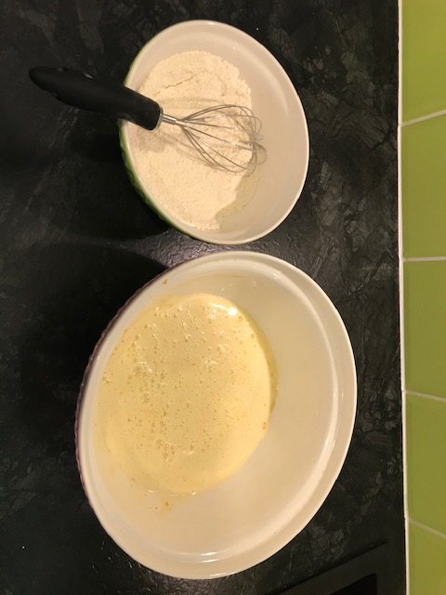**PREPARING DRY INGREDIENTS**

* In a bowl put the ground almond, flour baking powder and salt and mix well and leave aside.
* On a dry pan toast the almonds and let them aside for later

**PREPARING WET INGREDIENTS**

* On a separate bowl put the sugar and eggs and whisk until the mixture is pale yellow.
* Add the olive oil, orange juice and yogurt and whisk for a minute to blend.
* Add both extracts and the orange zest and whisk for another minute.

**PREPARING THE MIXTURE**

* Add the dry to the wet ingredients slowly a quarter at the time to allow the mixture to blend
* Add the toasted almonds and use a spoon or spatula to gently fold them in to the mixture.

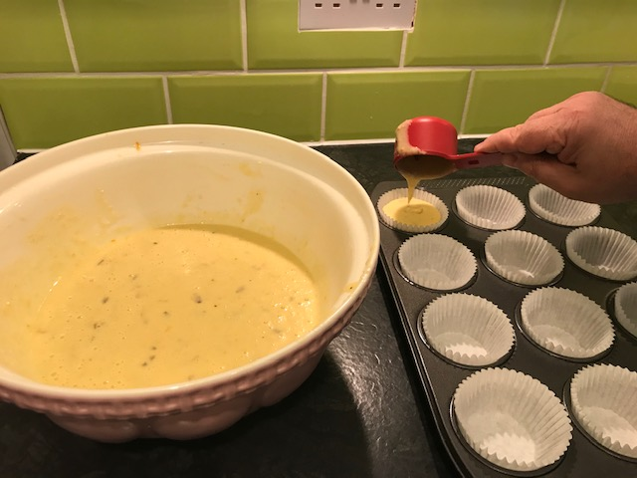

**AND FINALLY**

* Using a 1/3 cup scoop mixture in to the cases in the tray
* Place in the oven (middle shelf) and bake for 20-25 minutes.

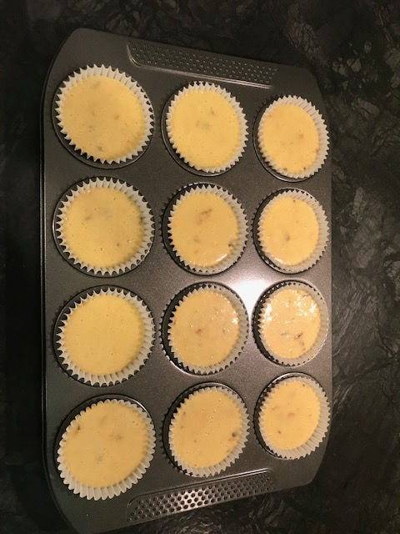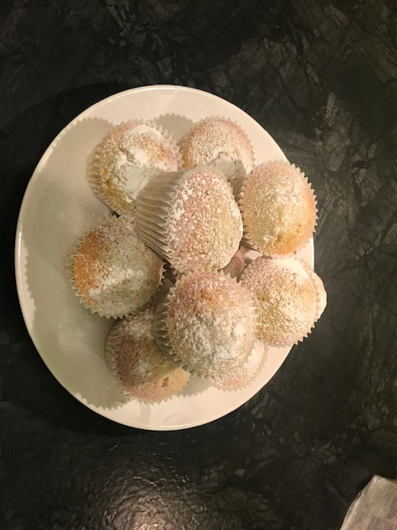

* Test with a clean skewer or tooth pick if they are dry. If not bake a couple more minutes.
* Take out and let them rest on a cooling rack.

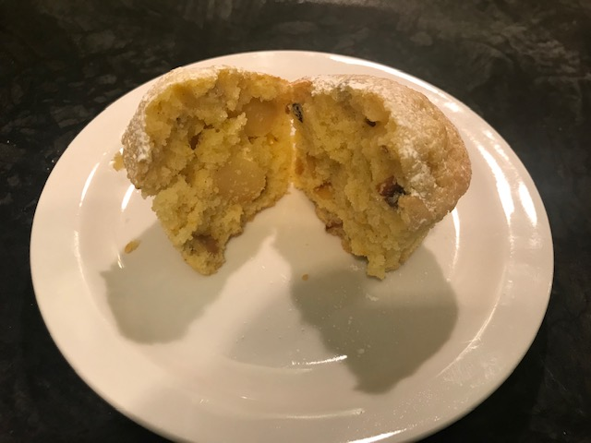

* Once they cooled down, dust with icing sugar (optional) and enjoy