Cocoa Trunk (Kormos)

**INGREDIENTS**

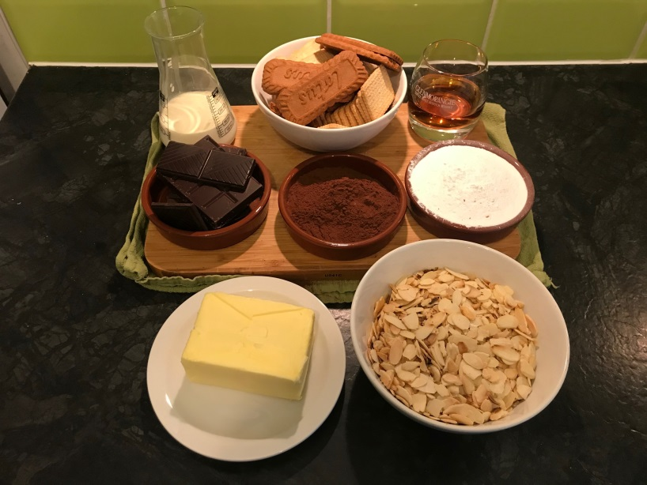

**1st mixture**

* 200 g chocolate couverture
* 150 g heavy cream 35% or evaporated milk

**2nd mixture**

* 250gr butter, at room temperature
* 100gr icing sugar
* 50ml alcohol (brandy, amaretto or coffee liquor) are the best to use.
* 50gr cocoa powder
* 270gr biscuits, lightly crushed (your choice)
* 200gr toasted flaked almonds

**METHOD**

**1st mixture**

* Chop the chocolate into pieces and put them in a bowl.
* Add the heavy cream.
* Cover with plastic wrap and heat in the microwave for 1 minute set at 700 watts.
* When ready, stir to combine and create a nice thick ganache.

**Tip**

Set aside for about 10-30 minutes, until it cools completely. You don’t want the butter to melt when you add it.

**2nd mixture**

* Beat the icing sugar, cocoa powder, and butter in a mixer.
* Add the ganache, alcohol and biscuits (cut them in half, do not crush or crumble them.
* Add nuts.
* Add them to the mixer’s bowl and gently stir with a spoon.

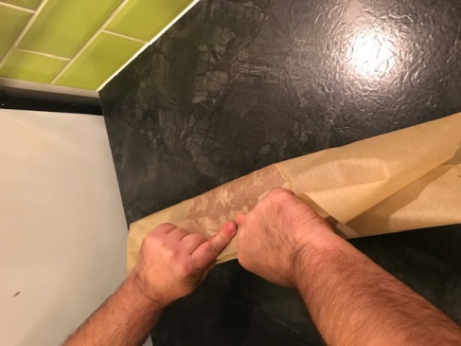

* Lay down a sheet of parchment paper and spread the mixture along the edge of the sheet.

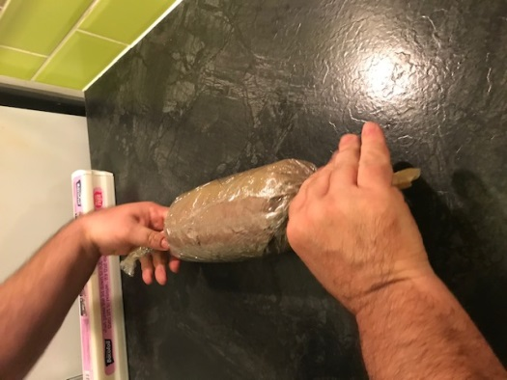

* Start to roll into a log. Halfway through rolling, add a sheet of cling film to help keep the roll the same size from beginning to end.

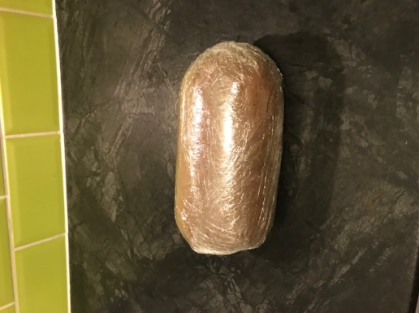

* Continue to roll until the log is securely wrapped and tie the ends like a piece of candy and place in the fridge or freezer for at least 2 hours.

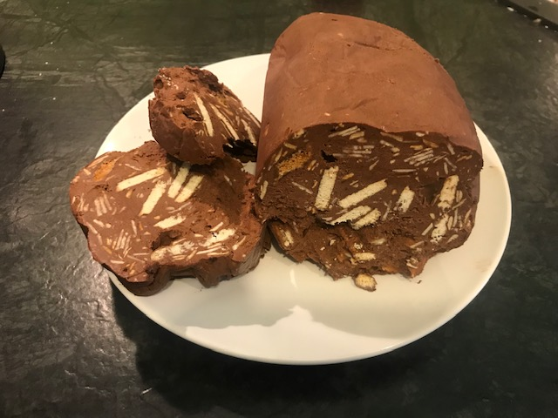

Cut a slice and enjoy