**Recipe for Greek Style Baked Fish (Plaki)**

**Serves 4**

**INGREDIENTS**

* 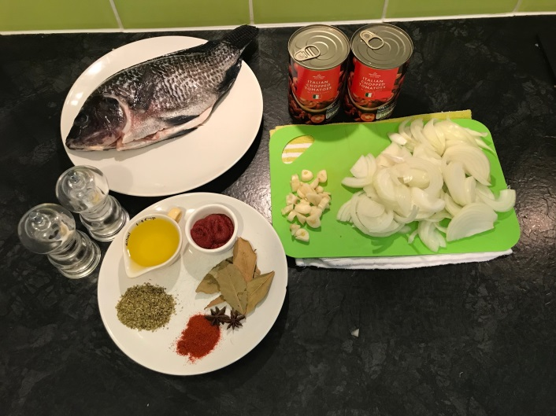1/4 cup olive oil
* 2 medium onions, thinly sliced
* 3 cloves garlic, chopped
* 2 tins Italian tomatoes, drained
* 2 teaspoons tomato paste
* 2 teaspoons dried oregano
* 2 teaspoons paprika
* 4 bay leaves
* 2 star anise
* salt
* pepper
* 1kg fresh white fish, whole or fillets
* 3 tablespoons fresh chopped parsley (optional)

**METHOD**

* Add the oil, onions, and garlic to a frying pan and saute on medium heat until the onions are translucent. This should take about 8-10 minutes.
* Add the tomato paste and sauté for a couple of minutes
* Add paprika, star anise, bay leaves, oregano, salt, and pepper and lower the heat to medium-low. Cook for about 7-10 more minutes until the sauce is lightly thickened.
* Heat the oven to 350 degrees Fahrenheit.
* Take a 9 x 13 baking dish and brush it with olive oil.
* Arrange the fish in the baking dish with the skin side up (if you are using fillets).
* Spread the tomato mixture on top of the fish.
* Sprinkle with the fresh parsley.
* Place the baking dish in the centre of the oven and bake for 20-30 minutes, until the fish is cooked all the way through.

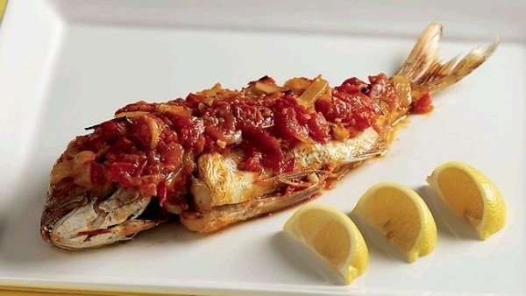

Serve with your choice of potatoes or rice and enjoy